**Question 1**  Make a calculator using Python with addition, subtraction , multiplication , division and power.

**Coding**   
def add(x, y):  
 return x + y  
def subtract(x, y):  
 return x – y  
def multiply(x, y):  
 return x * y  
def divide(x, y):  
 return x / y  
print("Select operation.")  
print("1.Add")  
print("2.Subtract")  
print("3.Multiply")  
print("4.Divide")  
choice = input("Enter choice(1/2/3/4): ")  
num1 = float(input("Enter first number: "))  
num2 = float(input("Enter second number: "))  
if choice == '1':  
 print("VALUE","=", add(num1,num2))  
elif choice == '2':  
 print("VALUE","=", subtract(num1,num2))  
elif choice == '3':  
 print("VALUE","=", multiply(num1,num2))  
elif choice == '4':  
 print("VALUE","=", divide(num1,num2))

else:  
 print("Invalid input")

**Output**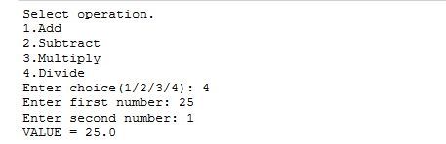

**Question 2** Write a program to check if there is any numeric value in list using for loop

**Coding**

my_list = [ 1, 6, 3, 5, 3 ,4]   
 print("Checking if 4 exists in list ( using loop ) : ")   
for i in my_list:   
 if(i == 4) :   
 print ("Element Is Exists")   
print("Checking if 4 exists in list ( using in ) : ")   
if (4 in my_list):   
 print ("Element Is Exists")

**Output  
**

**Question 3** Write a Python script to add a key to a dictionary

**Coding**d = {0:10, 1:20}

print(d)   
d.update({2:30})   
print(d)   
d.update({3:40})  
print(d)

**Output  
**

**Question 4** Write a Python program to sum all the numeric items in a dictionary

**Coding**

**Output**

**Question 5** Write a program to identify duplicate values from list

**Coding**

**Output**

**Question 6** Write a Python script to check if a given key already exists in a dictionary

**Coding**

**Output**